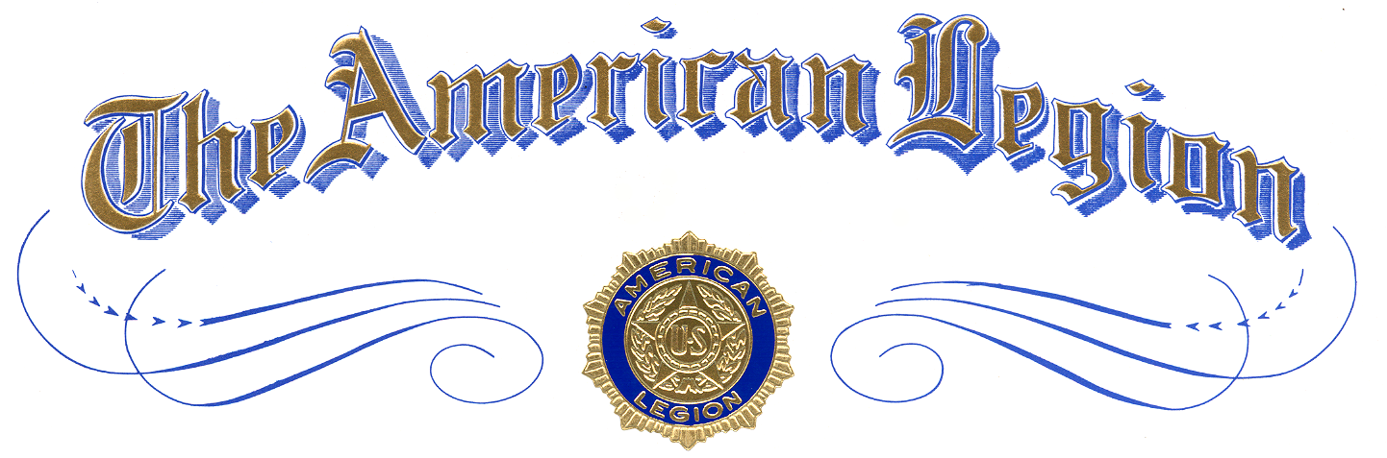

Winner of

School Level Oratorical

Winner Name
of
School Name

is awarded this certificate of Achievement
and Recognition for Excellence
in

The American Legion
National High School Oratorical Contest

Presented by
Commander, The American Legion Post XXX
at The American Legion Post XXX, City, Texas
Month Day, Year

Attest:

